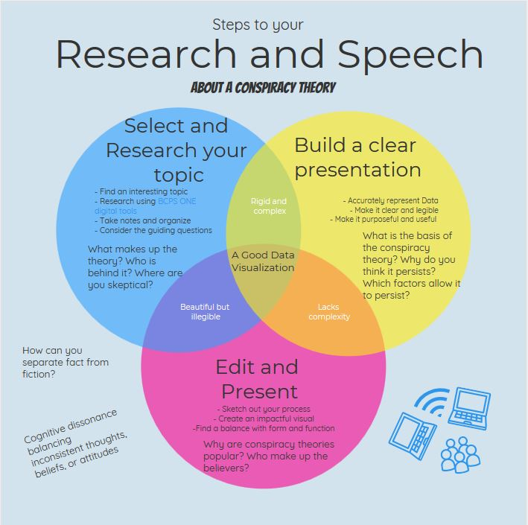

By the end of today (May 1, Day 1) each of us will have:
Selected a conspiracy theory,
Explored 3-5 sources,
Explained a possible rationale for the theory’s existence (audience, message purpose, author of message)

